ST. XAVIER’S COLLEGE

**(Affiliated to Tribhuvan University)**

**Maitighar, Kathmandu**



**Digital Logic Lab Assignment #15**

9.1. To verify the operation of 4 x 1 mux.

9.2. To verify the operation of 8 x 1 mux using 4 x 1 & 2 x 1 mux.

9.3. To verify the operation of 16 x 1 mux using 4 x 1.

**SUBMITTED BY:**

Gaurav Chaulagain

(017BSCIT014)

**SUBMITTED TO:**

|  |  |
| --- | --- |
| **Er. Saugat Sigdel**  **Lecturer** |  |
| **Department of Computer Science** | |

**Multiplexer (Data Selector):**

Multiplexer is a combinational circuit that allows digital information from several sources to be routed on a single line for transmission. A MUX accepts data from many input sources for transmission over a common shared line. A MUX has several data inputs and single output line. It also has a selection switch which permits digital data on any one of the inputs to be switched to the output line. A MUX has 2n inputs and n select bits.

**OBJECTIVE 9.1:**

**To verify the operation of 4 × 1 Mux.**

**THEORY:**

* It has 4 inputs and one selected output.
* Its symbol is:

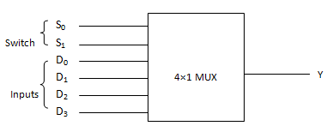

**TRUTH TABLE:**

|  |  |  |  |
| --- | --- | --- | --- |
| **DATA I/P** | **S0** | **S1** | **Y(O/P)** |
| D0 | 0 | 0 | D0 selected= D0 S0**’** S1**’** |
| D1 | 0 | 1 | D1 selected= D1 S0**’** S1 |
| D2 | 1 | 0 | D2 selected= D2 S0 S1**’** |
| D3 | 1 | 1 | D3 selected= D3 S0 S1 |

**CIRCUIT DIAGRAM:**

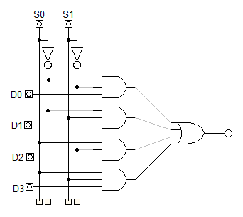

**OBSERVATION:**

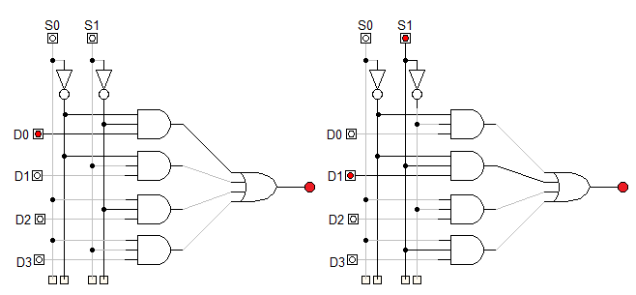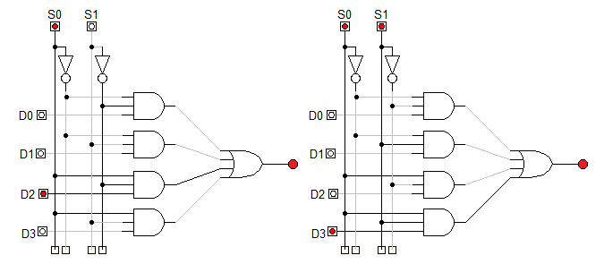

**OBSERVATION TABLE:**

|  |  |  |  |
| --- | --- | --- | --- |
| **DATA I/P** | **S0** | **S1** | **Y(O/P)** |
| D0 | 0 | 0 | D0 selected= D0 S0**’** S1**’** |
| D1 | 0 | 1 | D1 selected= D1 S0**’** S1 |
| D2 | 1 | 0 | D2 selected= D2 S0 S1**’** |
| D3 | 1 | 1 | D3 selected= D3 S0 S1 |

**CONCLUSION:**

Hence, the operation of 4×1 mux was verified.

**OBJECTIVE 9.2:**

**To verify the operation of 8 × 1 Mux USING 4×1 AND 2×1 MUX.**

**THEORY:**

* It has 8 inputs and one selected output.
* Its symbol is:

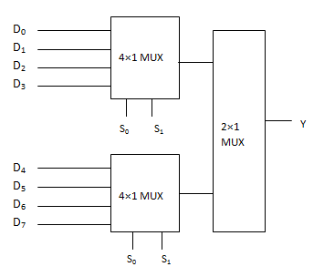

**TRUTH TABLE:**

|  |  |  |  |  |
| --- | --- | --- | --- | --- |
| **DATA I/P** | **S0** | **S1** | **S2** | **Y(O/P)** |
| D0 | 0 | 0 | 0 | D0 selected= D0 S0**’** S1**’** S2**’** |
| D1 | 0 | 0 | 1 | D1 selected= D1 S0**’** S1**’** S2 |
| D2 | 0 | 1 | 0 | D2 selected= D2 S0**’** S1**’** S2 |
| D3 | 0 | 1 | 1 | D3 selected= D3 S0**’** S1 S2 |
| D4 | 1 | 0 | 0 | D4 selected= D4 S0 S1**’** S2**’** |
| D5 | 1 | 0 | 1 | D5 selected= D5 S0 S1**’** S2 |
| D6 | 1 | 1 | 0 | D6 selected= D6 S0 S1 S2**’** |
| D7 | 1 | 1 | 1 | D7 selected= D7 S0 S1 S2 |

**CIRCUIT DIAGRAM:**

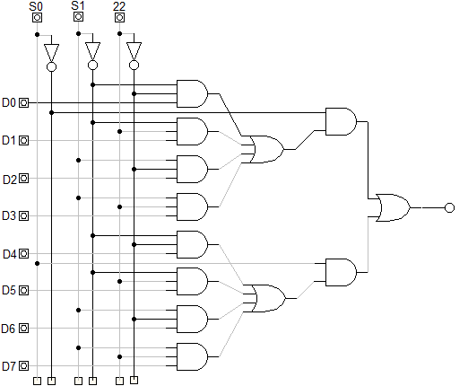

**OBSERVATION:**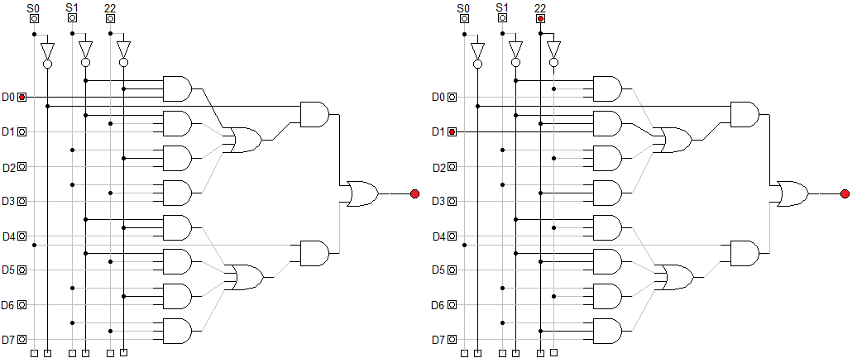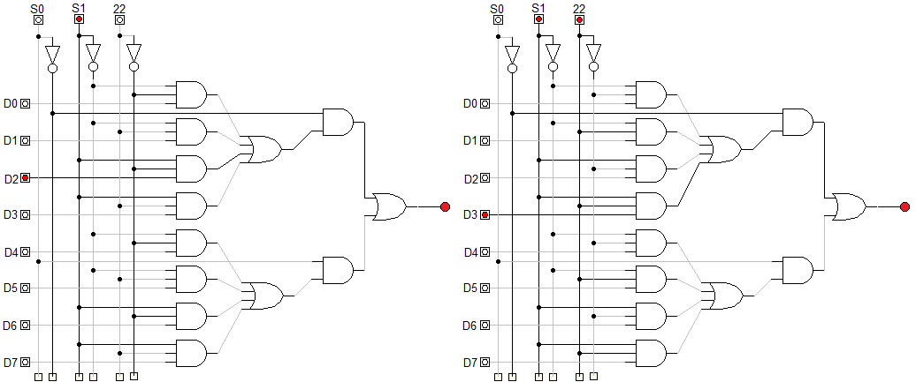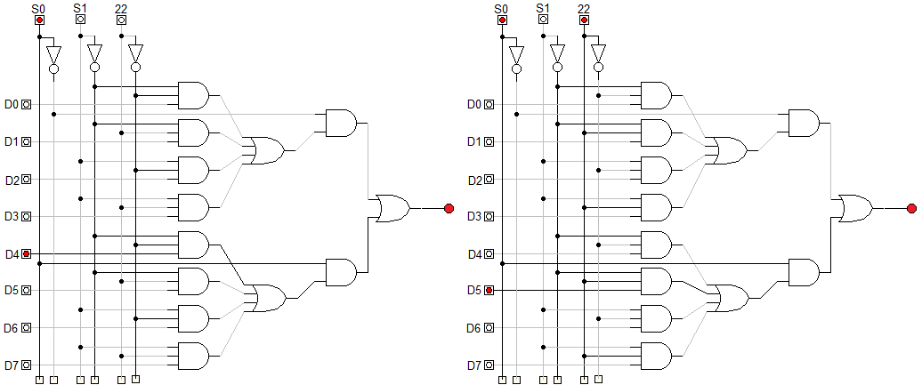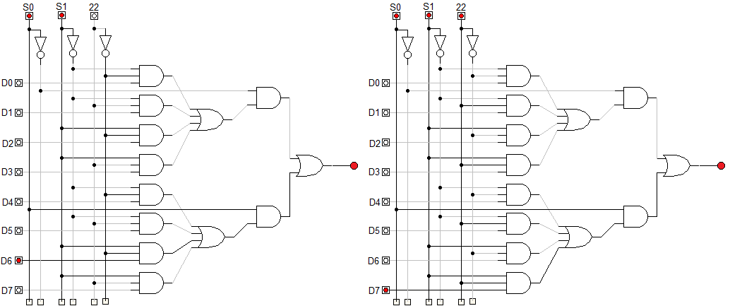

**OBSERVATION TABLE:**

|  |  |  |  |  |
| --- | --- | --- | --- | --- |
| **DATA I/P** | **S0** | **S1** | **S2** | **Y(O/P)** |
| D0 | 0 | 0 | 0 | D0 selected= D0 S0**’** S1**’** S2**’** |
| D1 | 0 | 0 | 1 | D1 selected= D1 S0**’** S1**’** S2 |
| D2 | 0 | 1 | 0 | D2 selected= D2 S0**’** S1**’** S2 |
| D3 | 0 | 1 | 1 | D3 selected= D3 S0**’** S1 S2 |
| D4 | 1 | 0 | 0 | D4 selected= D4 S0 S1**’** S2**’** |
| D5 | 1 | 0 | 1 | D5 selected= D5 S0 S1**’** S2 |
| D6 | 1 | 1 | 0 | D6 selected= D6 S0 S1 S2**’** |
| D7 | 1 | 1 | 1 | D7 selected= D7 S0 S1 S2 |

**CONCLUSION:**

Hence, the operation of 8×1 mux using 4×1 and 2×1 mux was verified.

**OBJECTIVE 9.3:**

**To verify the operation of 16 × 1 Mux USING 4×1 MUX.**

**THEORY:**

* It has 16 inputs and one selected output.
* Its symbol is:

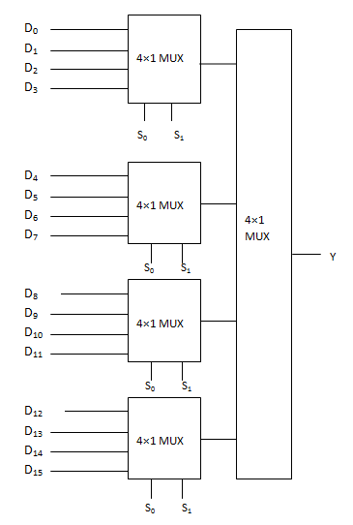

**TRUTH TABLE:**

|  |  |  |  |  |  |
| --- | --- | --- | --- | --- | --- |
| **DATA I/P** | **S0** | **S1** | **S2** | **S3** | **Y(O/P)** |
| D0 | 0 | 0 | 0 | 0 | D0 selected= D0 S0**’**S1**’** S2**’** S3**’** |
| D1 | 0 | 0 | 0 | 1 | D1 selected= D1 S0**’** S1**’** S2**’** S3 |
| D2 | 0 | 0 | 1 | 0 | D2 selected= D2 S0**’** S1**’** S2 S3 |
| D3 | 0 | 0 | 1 | 1 | D3 selected= D3 S0**’** S1**’** S2 S3 |
| D4 | 0 | 1 | 0 | 0 | D4 selected= D4 S0 S1 S2**’** S3**’** |
| D5 | 0 | 1 | 0 | 1 | D5 selected= D5 S0**’** S1 S2**’** S3 |
| D6 | 0 | 1 | 1 | 0 | D6 selected= D6 S0 ‘S1 S2 S3**’** |
| D7 | 0 | 1 | 1 | 1 | D7 selected= D7 S0**’** S1 S2 S3 |
| D8 | 1 | 0 | 0 | 0 | D8 selected= D7 S0 S1**’** S2**’** S3**’** |
| D9 | 1 | 0 | 0 | 1 | D9 selected= D7 S0 S1**’** S2**’** S3 |
| D10 | 1 | 0 | 1 | 0 | D10 selected= D7 S0 S1**’** S2 S3**’** |
| D11 | 1 | 0 | 1 | 1 | D11 selected= D7 S0 S1**’** S2 S3 |
| D12 | 1 | 1 | 0 | 0 | D12 selected= D7 S0 S1 S2**’** S3**’** |
| D13 | 1 | 1 | 0 | 1 | D13 selected= D7 S0 S1 S2**’** S2 |
| D14 | 1 | 1 | 1 | 0 | D14 selected= D7 S0 S1 S2 S3**’** |
| D15 | 1 | 1 | 1 | 1 | D15 selected= D7 S0 S1 S2 S3 |

**CIRCUIT DIAGRAM:**

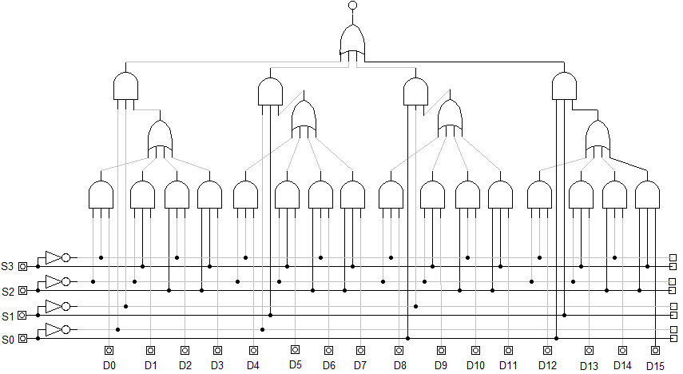

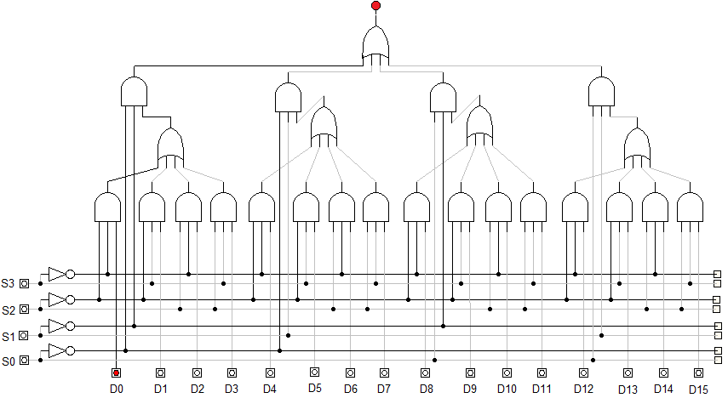

**OBSERVATION:** 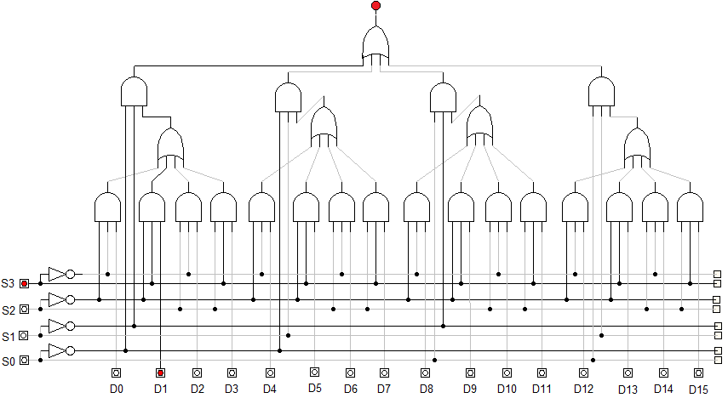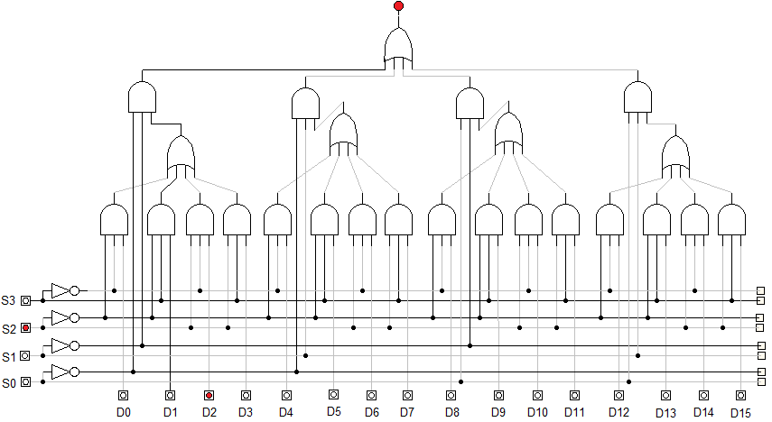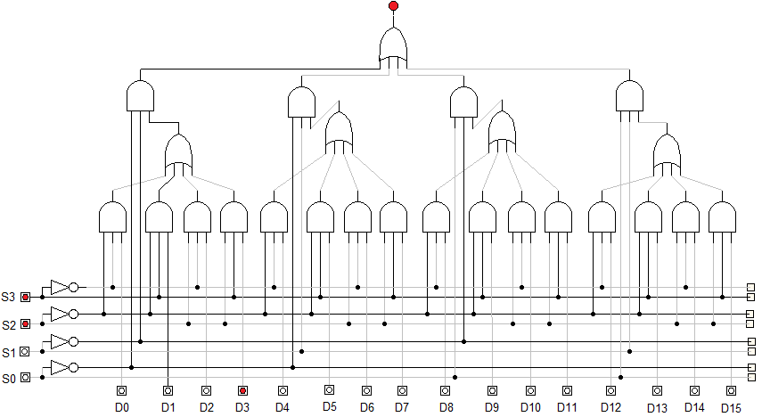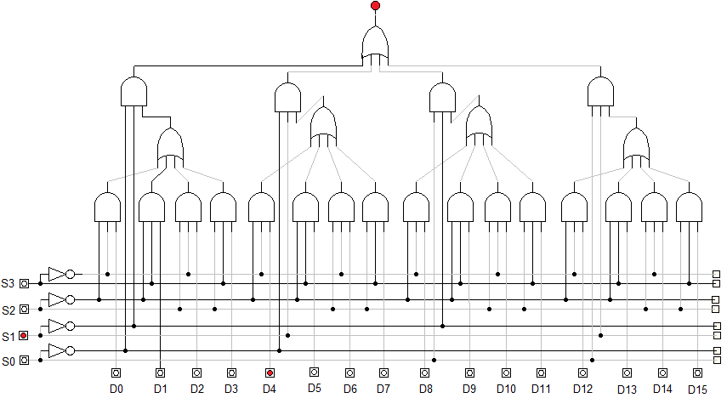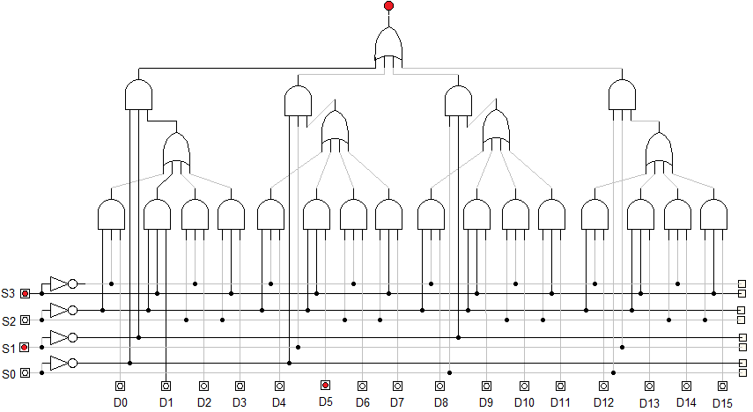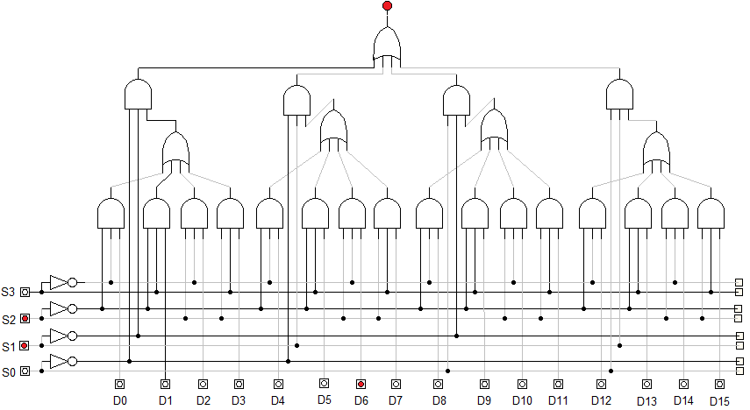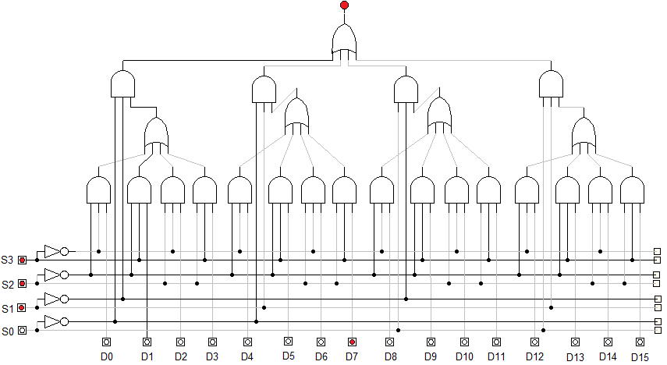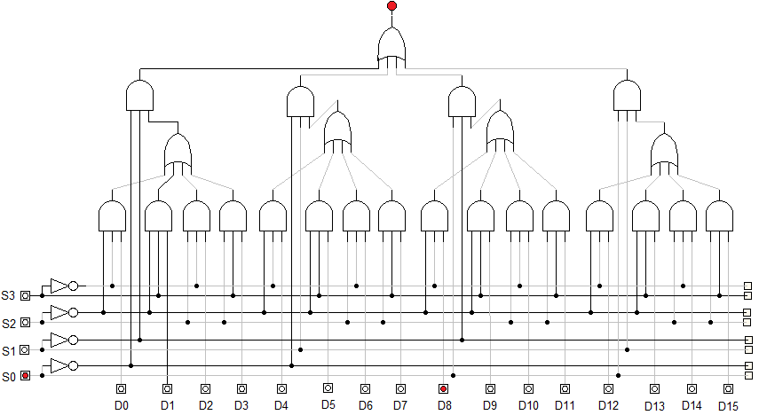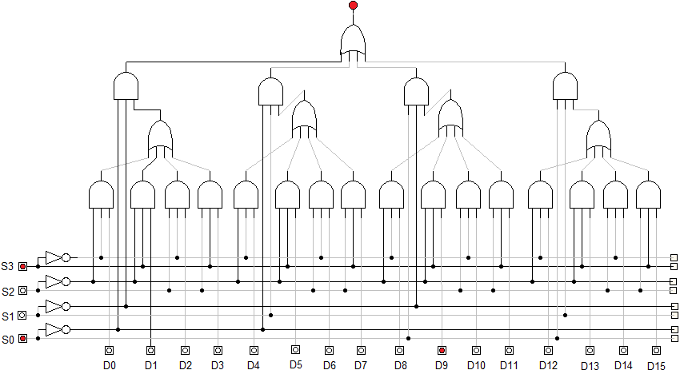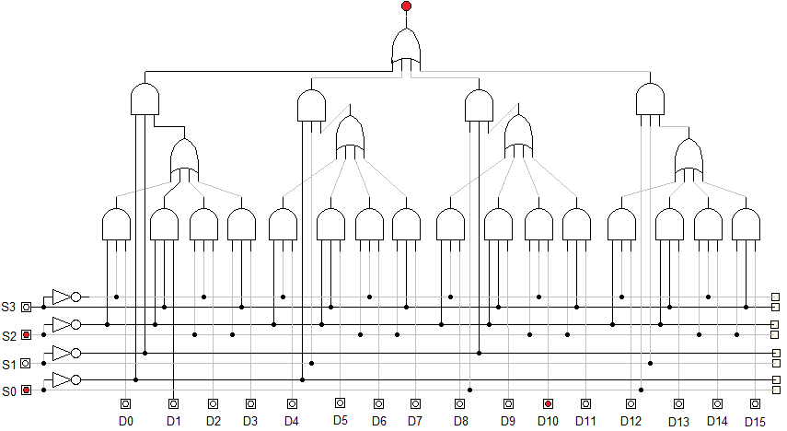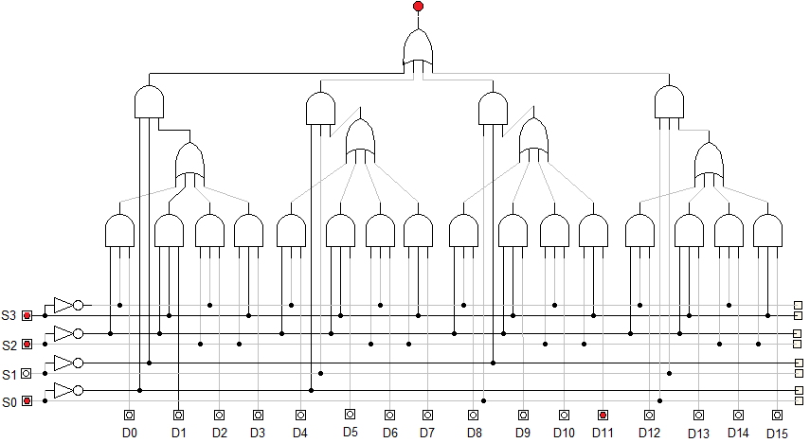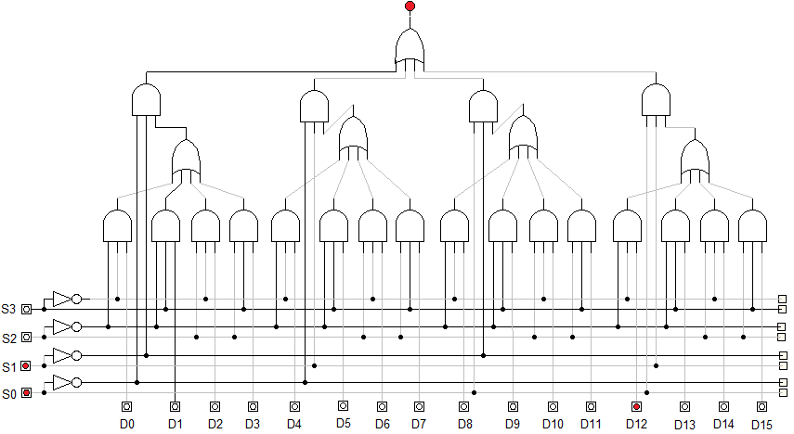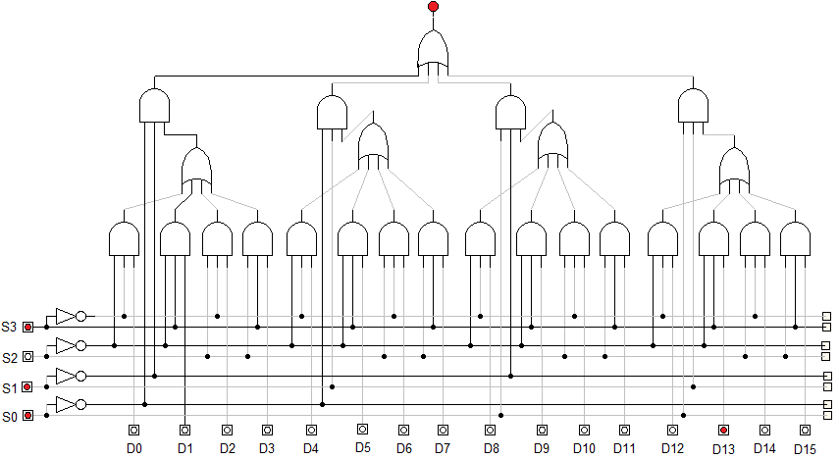 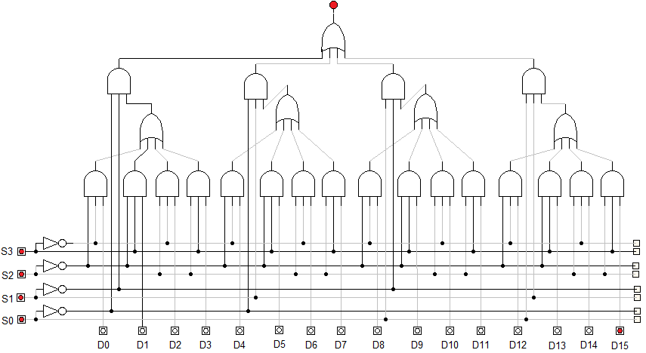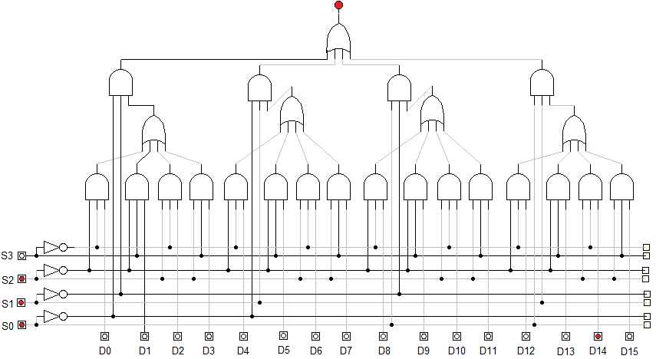

**OBSERVATION TABLE:**

|  |  |  |  |  |  |
| --- | --- | --- | --- | --- | --- |
| **DATA I/P** | **S0** | **S1** | **S2** | **S3** | **Y(O/P)** |
| D0 | 0 | 0 | 0 | 0 | D0 selected= D0 S0**’**S1**’** S2**’** S3**’** |
| D1 | 0 | 0 | 0 | 1 | D1 selected= D1 S0**’** S1**’** S2**’** S3 |
| D2 | 0 | 0 | 1 | 0 | D2 selected= D2 S0**’** S1**’** S2 S3 |
| D3 | 0 | 0 | 1 | 1 | D3 selected= D3 S0**’** S1**’** S2 S3 |
| D4 | 0 | 1 | 0 | 0 | D4 selected= D4 S0 S1 S2**’** S3**’** |
| D5 | 0 | 1 | 0 | 1 | D5 selected= D5 S0**’** S1 S2**’** S3 |
| D6 | 0 | 1 | 1 | 0 | D6 selected= D6 S0 ‘S1 S2 S3**’** |
| D7 | 0 | 1 | 1 | 1 | D7 selected= D7 S0**’** S1 S2 S3 |
| D8 | 1 | 0 | 0 | 0 | D8 selected= D7 S0 S1**’** S2**’** S3**’** |
| D9 | 1 | 0 | 0 | 1 | D9 selected= D7 S0 S1**’** S2**’** S3 |
| D10 | 1 | 0 | 1 | 0 | D10 selected= D7 S0 S1**’** S2 S3**’** |
| D11 | 1 | 0 | 1 | 1 | D11 selected= D7 S0 S1**’** S2 S3 |
| D12 | 1 | 1 | 0 | 0 | D12 selected= D7 S0 S1 S2**’** S3**’** |
| D13 | 1 | 1 | 0 | 1 | D13 selected= D7 S0 S1 S2**’** S2 |
| D14 | 1 | 1 | 1 | 0 | D14 selected= D7 S0 S1 S2 S3**’** |
| D15 | 1 | 1 | 1 | 1 | D15 selected= D7 S0 S1 S2 S3 |

**CONCLUSION:**

Hence, the operation of 16×1 mux using 4×1 mux was verified.